**TABLE OF CONTENTS**

1.0. INTRODUCTION 2

2.0. Evaluation of the usability of Spotify and YouTube music mobile application 3

2.1. Visibility of system status: 3

2.2. Match between the system and the real world: 4

2.3. User control and freedom: 4

2.4. Consistency and standards: 5

2.5. Error prevention: 5

2.6. Recognition rather than recall 6

2.7. Flexibility and efficiency of use 7

2.8. Aesthetic and minimalist design 7

2.9. Help users recognize, diagnose, and recover from errors: 7

2.10. Help and documentation: 8

3.0. Discussions on the assessment of the two applications and recommendations 9

4.0. Potential users of the music streaming platform 9

4.1. User persona of the music app 10

5.0. Activities and tasks of potential users 11

5.1. Justification of the activities and tasks of potential users 11

6.0. Design scenario for the music streaming app 12

7.0. Evaluation of the designed mid-fidelity prototype 12

8.0. Important features included in the design 17

8.1. Limitations of the design 19

8.2. Recommendations for improvement 19

9.0. Conclusion 21

References 22

# INTRODUCTION

Heuristic evaluation is a method of usability evaluation in which a group of evaluators examines a system's user interface (UI) against a set of heuristic principles or guidelines (Adam & Michele, 2015). Nielsen and Molich first introduced it in 1990, and it has since become a popular and widely used evaluation technique in the field of human-computer interaction (HCI) Nielsen and Molich (1990).

Heuristic evaluation seeks to identify usability issues and potential areas for improvement in a system's UI design before it is tested with users (Ayob, 2019). Because it does not necessitate the recruitment of users or the conduct of testing, heuristic evaluation can be a cost-effective and time-efficient method of identifying usability issues in a system. It does, however, have some limitations, such as the possibility of evaluators missing certain issues or disagreeing on the severity of issues (Briand et al., 2021).

In his seminal paper published in 1990, Jakob Nielsen proposed ten heuristic principles for heuristic evaluation. These ten heuristics are still widely applied and cited today. This ten-heuristic evaluation includes the following:

* **Visibility of system status:** The system should keep users informed about what is going on by providing appropriate feedback in a timely manner.
* **Match between the system and the real world:** Instead of system-oriented words, the system should use language and concepts familiar to the user. It should also adhere to real-world standards, presenting information in a natural and logical arrangement.
* **User control and freedom**: Users frequently make mistakes or change their minds, thus the system should make it simple for them to undo or redo actions.
* **Consistency and standards**: For consistency, the system should adhere to known conventions, allowing users to predict what will occur.
* **Error prevention**: The system should prevent errors wherever possible, through constraints and warnings.
* **Recognition rather than recall:** The system should reduce the user's memory load by displaying and making information and actions visible and easy to discover.
* **Flexibility and efficiency of use**: The system should cater to both novice and expert users, with shortcuts and customization options.
* **Aesthetic and minimalist design**: To avoid clutter, the system should only display information relevant to the user's tasks.
* **Help users recognize, diagnose, and recover from errors:** The system should generate error messages that are clear, concise, and actionable.
* **Help and documentation**: The system should provide help documentation, but it should not be used to explain the interface entirely.

# Evaluation of the usability of Spotify and YouTube music mobile application

Heuristic evaluation is a method of usability testing that involves evaluating an interface using a set of heuristic principles or guidelines. In this case, we'll use heuristic evaluation to rate the usability of the Spotify and YouTube Music apps, both of which offer free music streaming. The following is an evaluation of these two apps' heuristic evaluation:

## Visibility of system status:

The Spotify app has a clear and visible system status indicator at the top of the music playing screen, indicating the location of the song being played (playlist, or album). However, YouTube Music does not display the location of where the song is being played, making it difficult for the user to determine where the song is coming from, especially if the user has carried out other activities in the app.

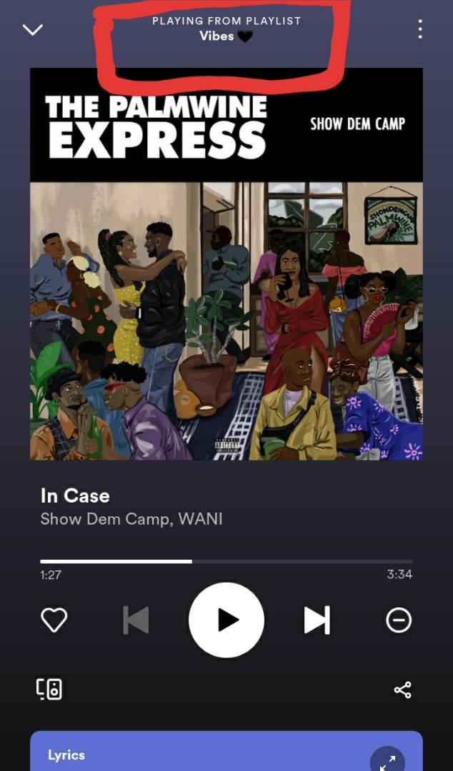 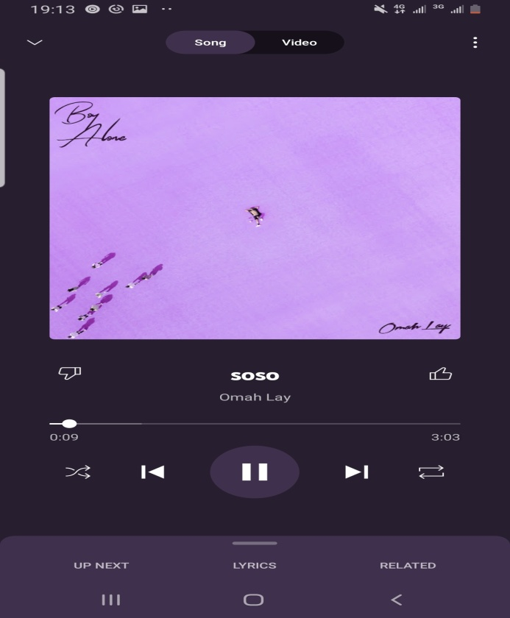

***Fig 1.0: music player screen on Spotify* *Fig 1.1. Music player screen on YouTube music***

## Match between the system and the real world:

Both apps adhere to industry-standard design patterns, making them simple for users to understand and use. They represent songs and playlists using real-world metaphors such as album covers, making it simple for users to understand the system.

## User control and freedom:

Both apps give users a good amount of control and freedom. On YouTube Music, for example, users can easily skip songs and create and manage playlists. The Spotify app, on the other hand, limits control over its playlist feature. In their free plan, users are unable to adjust playlists or properly view the arrangement of the songs on the playlist.

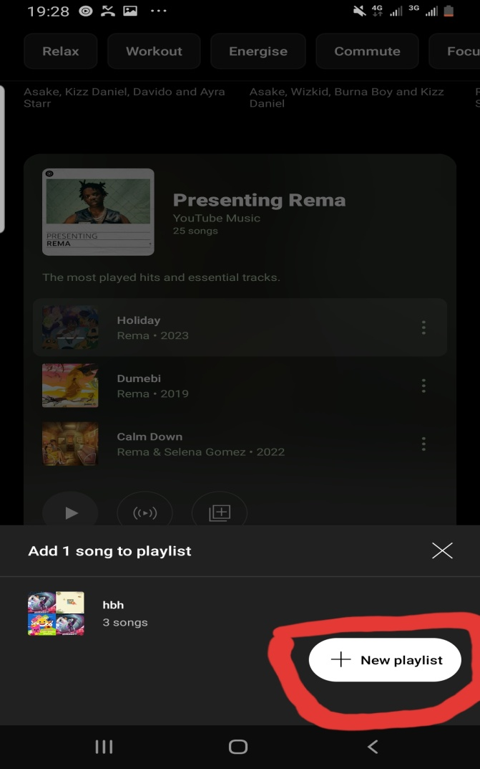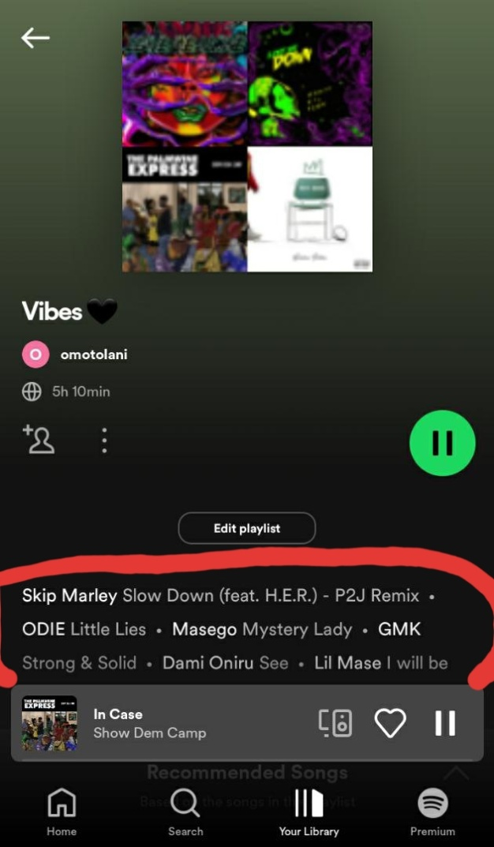

***Fig 1.2. Screen showing playlist on Spotify* || *Fig 1.3. Screen showing playlist on YouTube music***

## Consistency and standards:

Spotify's user interface is consistent across screens and devices, making it simple for users to navigate and use the app. However, the interface of YouTube Music is not always consistent across different screens and devices (desktop and mobile).

## Error prevention:

Error prevention measures, such as confirming playlist deletion and informing users of potential data usage when streaming over mobile networks, are in place. Both apps display error messages when users attempt to perform actions that are not permitted, such as skipping too many songs in a row or removing a song from a playlist. As shown in the figure 1.4 and 1.5 below, the YT music app provides error message by displaying that no internet is connected while trying to play a song, while the Spotify displays three dots that kept rolling for a long time, keeping users confused and waiting to know what happened.

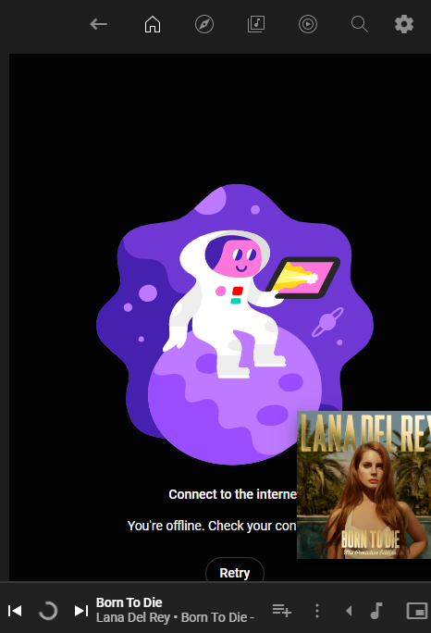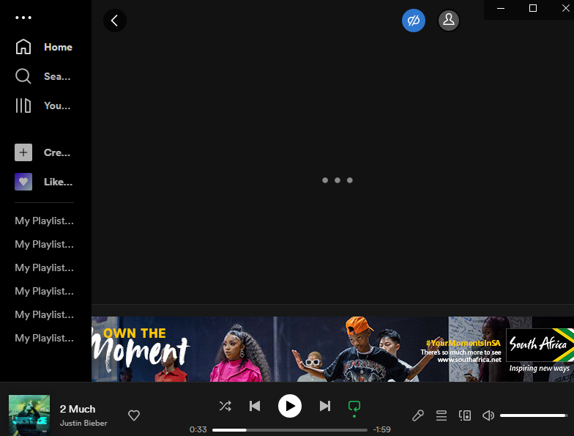

***Fig 1.4&1.5: How both systems has responded to users when error occurred***

## Recognition rather than recall

Spotify and YouTube Music display playlists and songs that users have recently played or added to their libraries, making it simple to find their favorite content.

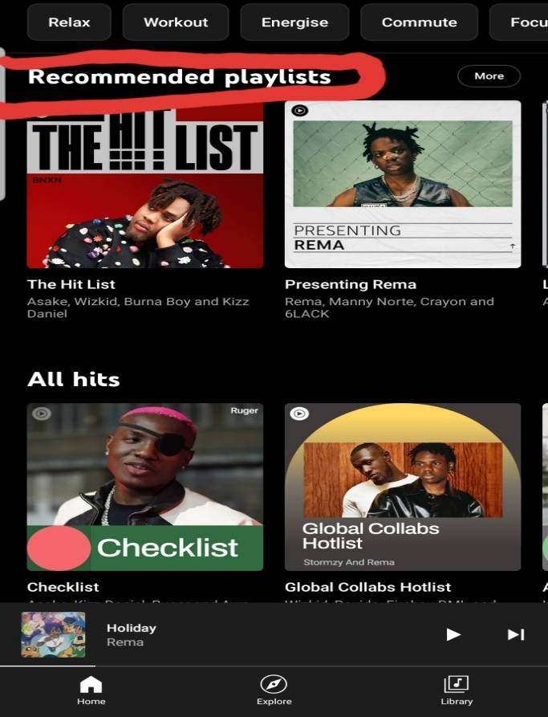

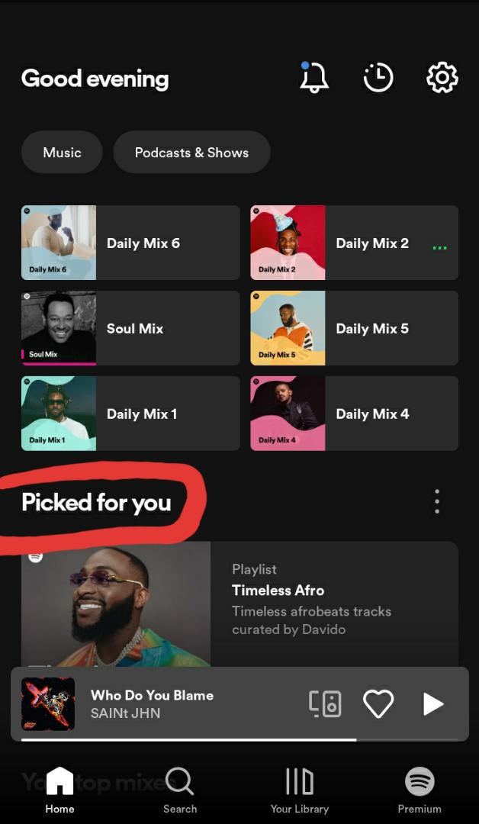

***Fig 1.6 &1.7 screen displaying playlist suggestion on Spotify and YT music app***

## Flexibility and efficiency of use

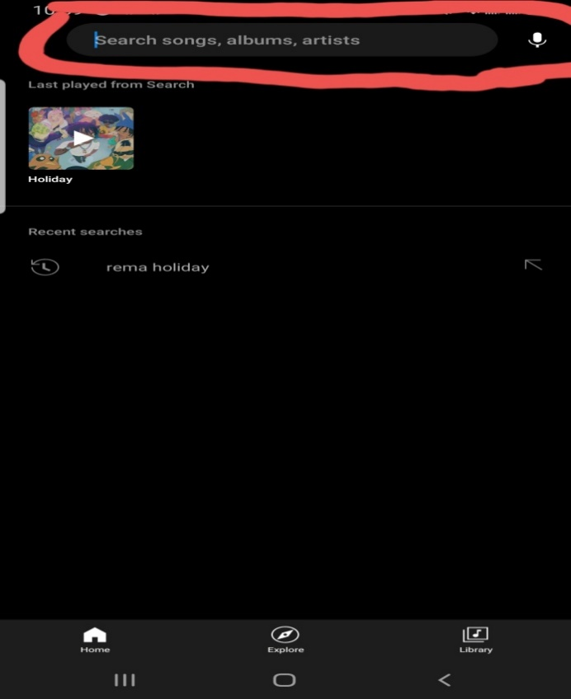It is critical to provide users with a high level of flexibility and efficiency of use, which both apps do. Users, for example, can easily search for and select songs, albums, and artists by typing or using the audio feature. The audio search feature is not available in Spotify's free plan.

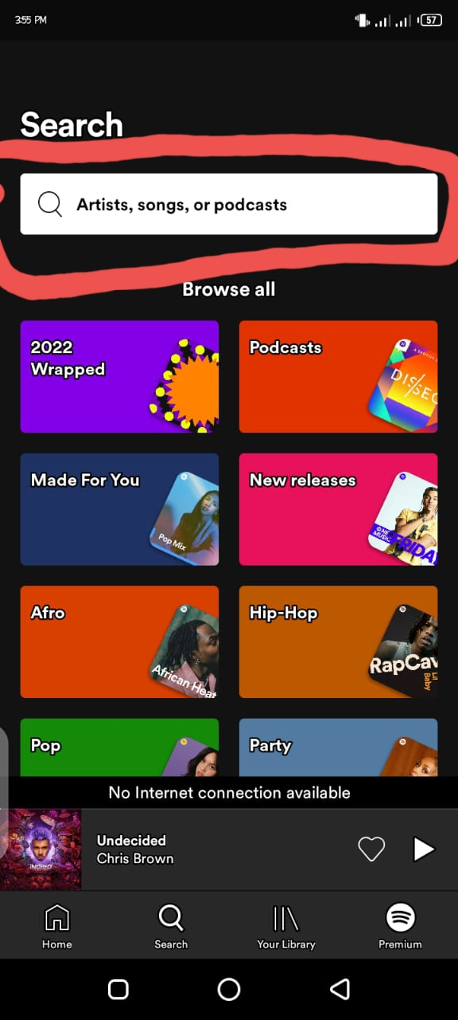

***Fig 6 & 7: Inclusion of flexibility in the both apps***

## Aesthetic and minimalist design

Both apps have a clean, modern design that focuses on the content. Both apps have a visually appealing interface, with album art and artist images prominently displayed.

## Help users recognize, diagnose, and recover from errors:

When an error occurs, such as when music cannot be played due to licensing limitations or a poor internet connection, both apps provide feedback and help. However, YouTube music will have to improve on this, especially during no or poor internet connections. YouTube music displays a pop-up saying "An error has occurred" which lasts for a few seconds and can be missed by the user.

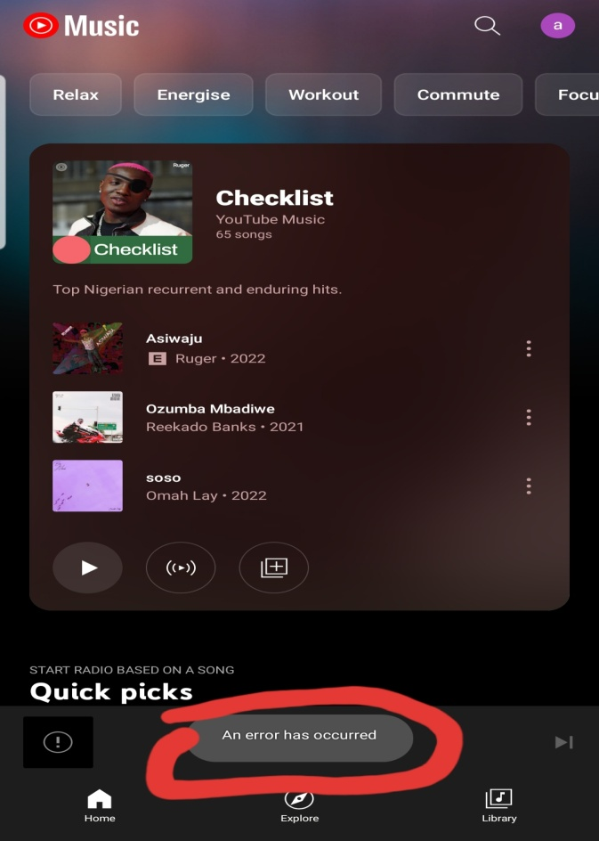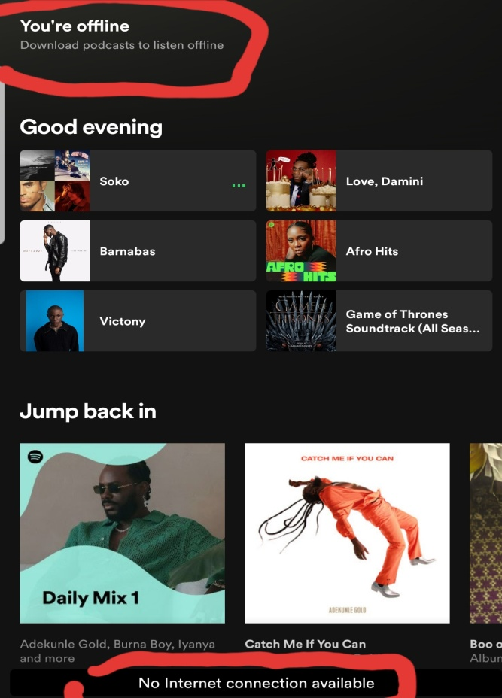

***Fig 1.8 screen displaying offline notification on Spotify |||| Fig 1.9 error screen notification on YT music***

## Help and documentation:

Both apps provide help and documentation, such as tutorials, FAQs, and customer support.

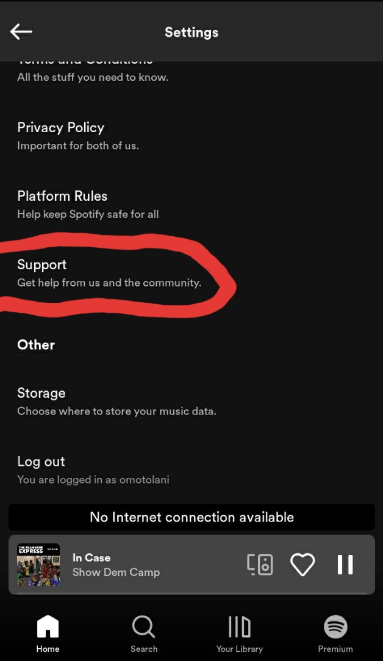 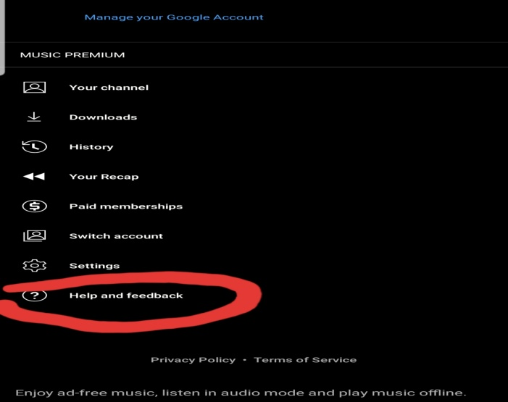

***Fig 2.0 Help & support screen on Spotify Fig 2.1 Help & support screen on YT music***

## Discussions on the assessment of the two applications and recommendations

Based on the heuristic evaluation of Spotify and YouTube Music mobile applications, several takeaways, and guidelines can be used to improve the usability of their interface.

To provide a good user experience on YouTube Music, consistency in design across different screens and devices is crucial. Use the same design elements like color, typography, and icons to make navigation and usage easier. Include error messages that clearly explain what went wrong and how to fix it. To prevent errors, limit the number of actions that are not allowed.

Allow users to create and personalize playlists, store songs, and generate radio stations based on their preferences. Keep the design simple and visually appealing with clear labels and buttons for easy navigation. Offer help resources such as FAQs and tutorials, and provide visual feedback using animations and transitions.

Make it easy for users to find their favorite content by displaying recently listened-to or added songs and playlists. Playback controls should be accessible from any screen with large buttons and clear labels for ease of use. Display the system status at the top of the screen, including the currently playing song and playlist name. Ensure accessibility for all users, including those with disabilities, through the use of clear language, alt text for images, and screen reader compatibility.

# Potential users of the music streaming platform

The potential users of Spotify and YouTube Music are individuals who are interested in listening to music online. These music streaming services are popular among music fans of all ages, including teenagers, young adults, and seniors (Kaufman, 2018; Li & Li, 2020). People of all ages and backgrounds use the services, from casual listeners to serious music connoisseurs. According to MusicWatch, 73% of music streamers in the United States are between the ages of 18 and 44, with 39% being between the ages of 18 and 24, and 34% being between the ages of 25 and 44. (MusicWatch, 2019). Furthermore, these services are used by people all over the world, with Spotify being available in over 80 countries and YouTube Music being available in over 70 (Spotify, 2021; YouTube Music, 2021).

According to a 2021 Statista survey, the majority of Spotify users are 18-24 years old (29%), followed by 25-34 years old (27%), and 35-44 years old (18%). Furthermore, the survey discovered that Spotify users are mostly male (52%) and live in cities (50%). (2021, Statista).

According to a 2021 App Ape Lab report, YouTube Music users are predominantly male (62.6%), aged between 18-24 years old (27.9%), followed by 25-34 years old (22.7%), and 35-44 years old (16.1%).

## User persona of the music app

User persona is a fictional representation of a typical user of a product or service, which is created based on research and data about the target audience (Fatmawati, 2021). It is a tool that designers and developers use to understand their users' goals, behaviors, motivations, and pain points, and to design products that meet their needs and expectations (Goldau & Frese, 2021).

A user persona typically includes demographic information such as age, gender, income, and education level, as well as psychographic information such as interests, hobbies, values, and personality traits. It also includes information about the user's goals, tasks, and behaviors related to the product or service, as well as their expectations, frustrations, and pain points (Goldau & Frese, 2021).

***Music enthusiasts and busy professionals***

Music enthusiasts and busy professionals use music streaming services differently. Music enthusiasts have varied music preferences and use streaming services to discover new music, create playlists, and share songs. Busy professionals have limited time but still want to enjoy their favorite music while on-the-go, relying on streaming services for quick and convenient access to their playlists and songs during commutes or breaks.

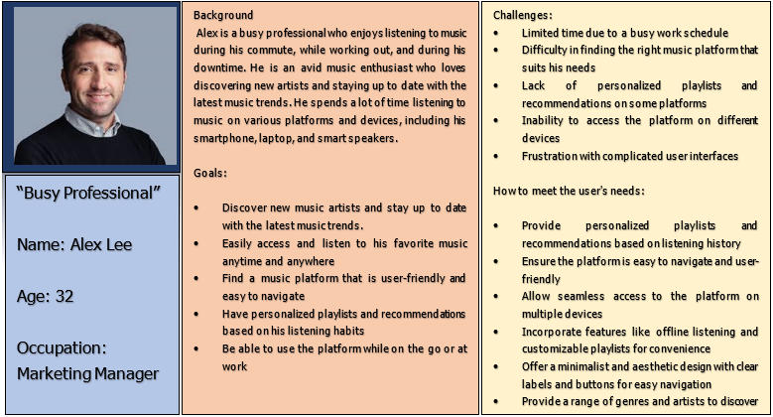

***Fig 2.2: User persona for a busy professional***

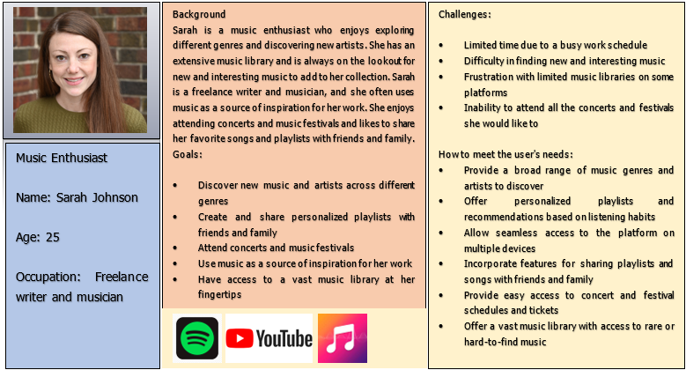

***Fig 2.3: User persona for music enthusiast***

# Activities and tasks of potential users

Here are some possible activities and tasks of potential users of the music streaming app:

**Searching for music:** Users can search for specific songs, artists, or albums to listen to. They can also look for playlists made by other users or by the music streaming service itself.

**Creating playlists:** Users can make playlists for various moods, occasions, or genres. They can include songs from the music library or their personal collection.

**Discovering new music**: Users may want to find new music that appeals to their tastes. They can search for new artists and genres or browse recommendations based on their listening history.

**Sharing music:** Users may want to share their music discoveries with friends and family via social media or the sharing features of the music streaming app.

## Justification of the activities and tasks of potential users

* ***Finding music:*** Users want to easily locate and listen to their favorite songs/artists, or they may switch to another app.
* ***Playlist creation:*** Users desire to create customized playlists for various moods/occasions. Music apps can enhance the listening experience by allowing effortless playlist creation.
* ***Music discovery:*** Users seek to explore new music that aligns with their preferences. Personalized suggestions and search functionality can aid in music discovery.
* ***Music sharing:*** Sharing musical discoveries with friends and family is popular. Incorporating user-friendly sharing options can boost user engagement and attract new users.

## Design scenario for the music streaming app

***Scenario one: Sarah's Workout Playlist***

Sarah is a fitness enthusiast who uses music to motivate herself during her workouts. She joined a new music streaming service and uses the following features:

* ***Signing up:*** Sarah creates a new account and specifies her music preferences.
* ***Discovering the workout playlist feature:*** Sarah explores the app and finds the "Create a Workout Playlist" button.
* ***Customizing her workout playlist:*** Sarah selects the workout type and duration, and the music streaming service creates a custom playlist for her.
* ***Adding songs to the playlist:*** While working out, Sarah adds more upbeat songs to her playlist using the app's search function.
* ***Saving and sharing the playlist:*** After her workout, Sarah saves the playlist and shares it with her fitness group on social media.

***Scenario 2: Personalized Music Discovery for Music Enthusiasts***

"Amy, a music enthusiast who loves discovering new and diverse genres, often struggles to navigate through the vast library of songs on different music streaming services. Our proposed solution is a personalized music discovery feature that suggests new songs and artists based on her preferences. Upon logging in, Amy is greeted with a personalized home screen displaying recommended songs and artists based on her listening history, favorite genres, and playlists. She can easily browse and add recommendations to her playlist with a single tap. This feature saves Amy time and effort, provides a more enjoyable listening experience, and enhances her connection with the app."

# Evaluation of the designed mid-fidelity prototype

***Visibility of system status –*** The visibility of the system is aligned well with the usability principles, with a color contrast that enables the user’s easy accessibility to the app. The cards shown in the red box, are well aligned to enhance visibility and the font sizes helps users to easily understand the content of the app. The bottom slider in the yellow box shows that something is either playing or is being played.

-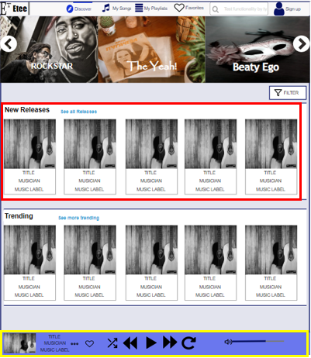

***Fig 2.4: The system provides visibility for users***

***Match between system and real world –*** Words and phrases that are easy for users to understand have been adopted as shown in the figure 2.5 below, users will not find them difficult to understand and familiarize with.

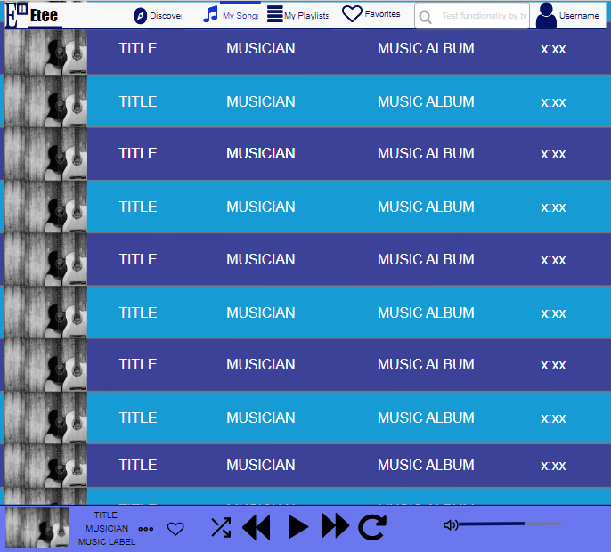

***Fig 2.5: The system matches existing music players***

***User control and freedom –*** This has been ensured through the provision for features that allows users to like songs and save them as favorites. Provisions of features that also allows them to next a song, repeat option, increase volume and so on.

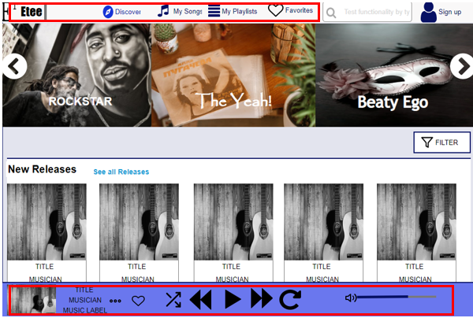

***Fig 2.6: Users are given control and freedom***

**Consistency and standardization ­–** Thumbnail style is consistent with that which is used by existing music playing platforms, as well as commonly used terms such as “Trending music”, “new releases” etc.

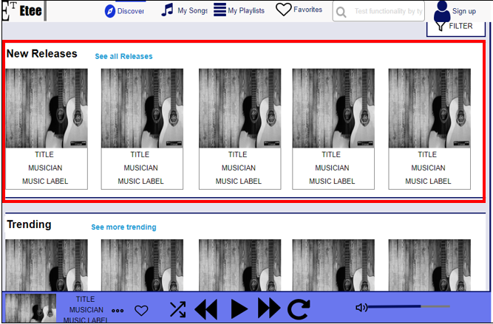

***Fig 2.7: Consistency and standard in design***

**Error prevention -** In the sign-up page, the option to show password has been included to enable users to see if they have typed the right passwords.

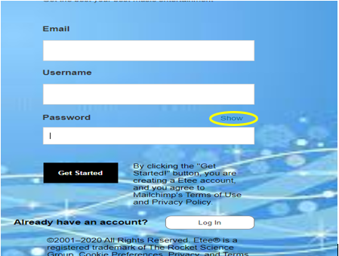

***Fig 2.8: How the system prevents error***

**Recognition rather than recall** – The music app has been designed to allow users with recognition of the contents of the interface instead of letting them recall them. Users do not need to check up dictionaries to understands words like “personal playlists”, “Team playlist” and so on, as it is shown in the figure 2.9 below.

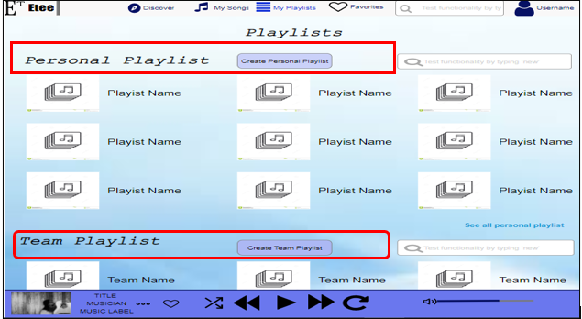

***Fig 2.9: Recognition rather than recall in design***

***Flexibility and effectiveness of use*** – Provision of filter for users has provided more flexibility for them as shown in the figure below.

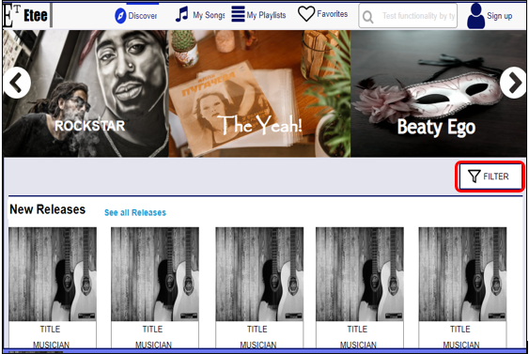

***Fig 3.0: Provision of filter as a flexibility feature***

***Aesthetics and minimalistic design –*** the interface of the music app have been designed with simplicity as shown in the red box, with use of current music stars the users are familiar with. Also, minimalistic design is ensured in the thumbnails, details that are not needed by users are not included.

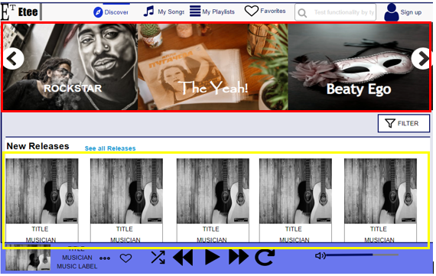

***Fig 3.0: Aesthetic and minimalistic design***

***Help and documentation –*** Under the footer section of the page, is provision for help, users can communicate with the admin through variety of options presented in the “Get in touch with us today” page.

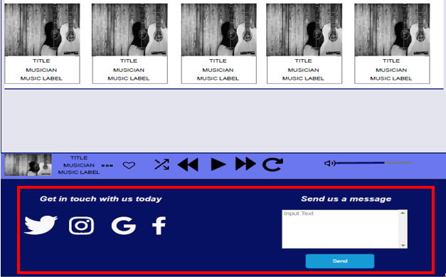

***Fig 3.1: How the app has provided help***

# Important features included in the design

Provision for sign up and login page for new and existing users

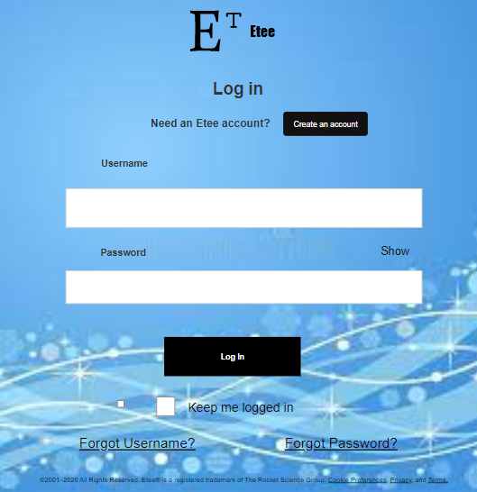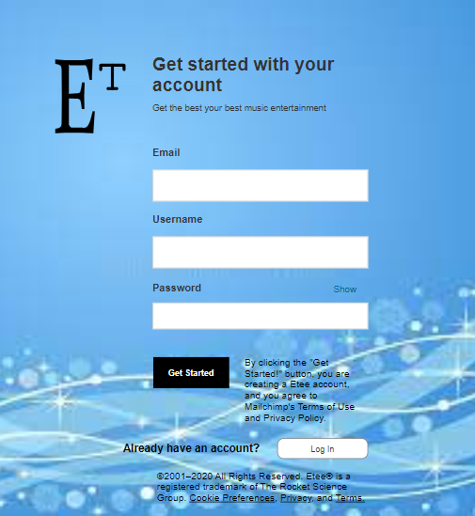

***Fig 3.2: sign and login page***

Users can utilize the search functions on the app to look for contents both online and offline.

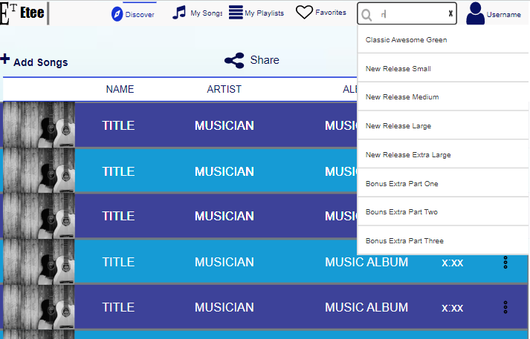

***Fig 3.3: Search function***

Users can create their own personal playlist on the app.

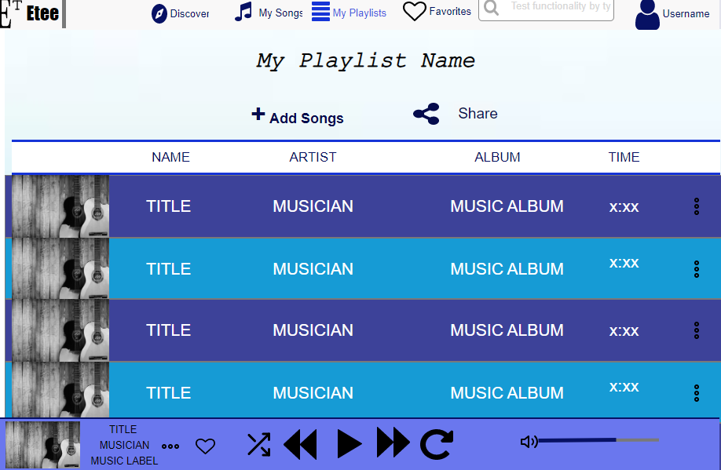

***Fig 3.4: Allows users to create personal playlist***

Users can create group playlist

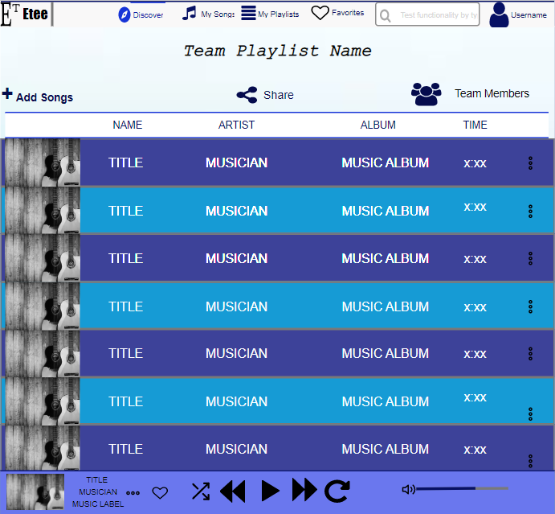

***Fig 3.5: Team playlist options***

## Limitations of the design

* **Lack of separate page for albums of specific artiste –** Users could be interested in the collection of a particular artiste. This will enable them to choose from a wide variety of their songs.
* **Insufficient flexibility:** Provisions for undo and redo options should be considered. Which will increase flexibility of use.
* The home key is used as the only exit means, the writer should use icons that allows users to go back.

## Recommendations for improvement

Although the mid-fidelity prototype was created with adequate care for user usability of the interface and the app as a whole. There are certain shortcomings that have been found that may make the system more difficult to use. The following suggestions may be taken into account:

* The inclusion of multilingual alternatives in the app should be given thought; doing so would promote interaction with a worldwide audience, improve the rate of conversion, and help businesses forge closer bonds with their target market.
* The shuffle and repeat features must be integrated in the general design as they will provide customers more options while using the app.
* Having user profiles on the app provides accurate market research evaluations and helps to better understand the demographics of app users.

## Conclusion

In conclusion, music streaming services have become an integral part of our daily lives, providing us with access to millions of songs from a variety of genres and artists. With the increasing demand for personalized and customizable experiences, music streaming services have continued to evolve and introduce new features that cater to the needs and preferences of their users. Through the evaluation of popular music streaming services such as Spotify and YouTube Music using heuristic evaluation, we can see that they have made significant efforts to improve the usability of their platforms. By understanding the potential users of these services and their tasks and activities, a mid-fidelity prototype has been created that is user-centered, efficient, and enjoyable to use. The scenario design presented also highlights the potential for the music app to offer personalized and custom features that cater to specific user needs. As technology continues to advance, we can expect music streaming services to become even more sophisticated and user-friendly, providing a more enjoyable and immersive listening experience for all music lovers.

## References

Adam, B. and Michele, M. (2015) “Identifying and treating phonological and motor errors in acquired speech impairment,” *Frontiers in Psychology*, 6. Available at: https://doi.org/10.3389/conf.fpsyg.2015.65.00038.

Ayob, A. (2019) “Comparison between conventional and Digital Essay Writing Assessment System: Consumer Concept and user friendly,” *Research in World Economy*, 10(2), p. 96. Available at: https://doi.org/10.5430/rwe.v10n2p96.

Briand, L. *et al.* (2021) “A semi-personalized system for user cold start recommendation on music streaming apps,” *Proceedings of the 27th ACM SIGKDD Conference on Knowledge Discovery & Data Mining* [Preprint]. Available at: https://doi.org/10.1145/3447548.3467110.

Chitale, D. (2019) “Ancillary studies: Contribution to error and error prevention,” *Error Reduction and Prevention in Surgical Pathology*, pp. 77–106. Available at: https://doi.org/10.1007/978-3-030-18464-3_5.

Fatmawati, A. (2021) “Evaluasi usability Pada learning management system OpenLearning Menggunakan system usability scale,” *INOVTEK Polbeng - Seri Informatika*, 6(1), p. 120. Available at: https://doi.org/10.35314/isi.v6i1.1881.

Goldau, F.F. and Frese, U. (2021) “Learning to map degrees of freedom for assistive user control,” *The 14th PErvasive Technologies Related to Assistive Environments Conference* [Preprint]. Available at: https://doi.org/10.1145/3453892.3453895.

Im, H. and Kim, N.W. (2016) “Three personas of potential high-resolution music users,” *Proceedings of the 2016 CHI Conference Extended Abstracts on Human Factors in Computing Systems* [Preprint]. Available at: https://doi.org/10.1145/2851581.2892552.

Kaufman, G. (2018, September 7). Who is using Spotify? Here's everything you need to know. The Daily Dot. Retrieved from https://www.dailydot.com/upstream/who-is-using-spotify/

Kim, J. and Fritsch, M.H. (2021) “Semantic sense as simplicity for design representation,” *The International Journal of Visual Design*, 15(2), pp. 1–23. Available at: https://doi.org/10.18848/2325-1581/cgp/v15i02/1-23.

Li, Y., & Li, H. (2020). User satisfaction and continuance intention of music streaming apps: An empirical study of Spotify and Apple Music. Journal of Retailing and Consumer Services, 53, 101981.

Lolade, S. (2021) *Heuristic evaluation on usability of Educational Games: A Systematic Review*. Available at: https://www.researchgate.net/publication/337018628_Heuristic_Evaluation_on_Usability_of_Educational_Games_A_Systematic_Review (Accessed: March 27, 2023).

MusicWatch. (2019). Annual Music Study 2019: Music Consumption, Attitudes and Habits. Retrieved from <https://musicwatchinc.com/wp-content/uploads/2019/04/MusicWatch-2019-Annual-Music-Study-Report.pdf>

Nielsen, J. (1994). Heuristic evaluation. In Usability inspection methods (pp. 25-62). John Wiley & Sons, Inc.

Nielsen, J., & Molich, R. (1990). Heuristic evaluation of user interfaces. In Proceedings of the SIGCHI conference on human factors in computing systems (pp. 249-256).

Salminen, J., Jung, S.-G. and Jansen, B. (2022) “Developing persona analytics towards persona science,” *27th International Conference on Intelligent User Interfaces* [Preprint]. Available at: https://doi.org/10.1145/3490099.3511144.

Shneiderman, B., & Plaisant, C. (2010). Designing the user interface: strategies for effective human-computer interaction. Pearson Education.

Virzi, R. A. (1992). Refining the test phase of usability evaluation: How many subjects is enough? Human Factors, 34(4), 457-468